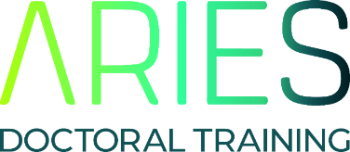
Request for Non-Participation:
Mandatory Training
If you wish to request leave for non-participation in a mandatory ARIES cohort training event, please complete the following form. Please note that absence will only be approved in exceptional circumstances. You will be asked to detail how you plan to mitigate the missed training.

Name
Email
University/ Institute
Department/School/Division
Year of study
(for PT PGRs please give equivalent year of FT study)
Date(s) absence requested
Have you previously requested non-participation in an ARIES mandatory event? | Yes / No (delete where applicable)  If Yes, please specify:  Event(s):  Date(s):
Please select reason for request | ☐ Fieldwork ☐ Training workshop  ☐ Personal ☐ Conference attendance
Justification for Request
if your request is due to conference attendance or training workshop, please detail why this particular event and why at this particular time.
Training to be undertaken to mitigate lost DTP training
please detail which training you will undertake (including dates) to mitigate lost DTP training
Supporting Statement from PhD supervisor
Recalling your commitment to support ARIES training events and the attendance of your PGR, please comment on why you have been unable to fulfil this commitment at this time.
Date
Signature of Student
Signature of Supervisor
Please email completed application forms to aries.dtp@uea.ac.uk

